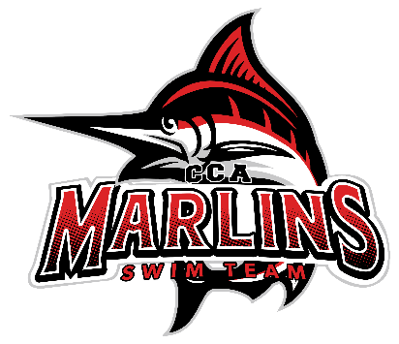

Marlins Short Course Parent Meeting Recap September 7, 2025
Welcome and Introductions
- Coach Amina introduced all coaches, board members, and the coach search committee:
- Coaches:
- Coach Susan
- Coach Gorby
- Coach Jamie
- Coach Buffy
- Coach Casey
- Assistant Coaches
- Board Members:
- President: Brooke Spurlock
- VP: Juliet Vile
- Treasurer: Julie Miller
- Secretary: Whitney Combs
- Parent Coach Search Committee:
- Ginger Avis
- David Blevins
- Andrea Carter
- Parent Volunteer Coordinator: Amanda Foutz
- Announcement: Coach Amina announced her new role as Executive Director and interim Head Coach while the committee searches for a new Head Coach and/or Age Group Coach.
Website Overview
- Coach Amina walked through the entire team web site (https://www.gomotionapp.com/team/vacca/page/home), highlighting:
- Registration and FAQs
- Meets & Events: Demonstrated how to sign up for meets and select swimmer events.
- Job Signups: Explained the 6-session per family responsibility; noted that families will incur a fine if not completed by the end of the season.
- Swimming 101: A dropdown packed full of information.
- Safe Sport, Bylaws, Forms, Tudor Scholarship, and Newsletter (currently on hold).
- Records: Noted they are being updated.
- Other Documents: Includes Board Minutes.
Survey Results
- Main requests identified from the survey included:
- Improvement in communication and feedback from coaches.
- Better understanding of how meets are chosen.
- Timely posting of hotel information for meets.
- Coach Amina addressed these concerns and discussed the implementation of new strategies to enhance these areas.
Parent Meetings
- Announced that there will be three parent meetings per season:
- Start of the short course (in person)
- One in December or January (virtual)
- One prior to Long Course (virtual)
Introduced Sue Munson- Marlins Meet Referee
-Sue touched on importance of character and disciplines swimming teaches and that it’s not just about swimming fast.
-Also spoke on importance of parent volunteers and without meets cannot be legally held.
-Marlins need more parents looking into becoming Meet Referee.
Amanda’s Power Point Presentation
- Amanda reviewed all volunteer areas and the rollout of the team app, BAND. Noted that when you sign into BAND, please note your child’s name and swim group.
(See file 25/26 Parent Volunteer Power Point)
Swim and Tri Setup
- Noted the setup on the pool deck for Swim and Tri.

